Social Implications: Licensing
si_licensing.html — Social Implications

EULAS, Licensing, Copyright, Copyleft, Creative Commons and Piracy

Software and ownership - know your rights and responsibilities
Software is not something you can touch.
Software is a product of the mind.
This means software is regarded as Intellectual Property and is legally protected by copyright law.
Copyright applies to products of the mind such as writing (fiction & non-fiction), music, visual arts (painting, photography, movies, etc.)
The C in a circle symbol is the international symbol for copyright.
The topic of Intellectual property is a complex one. Copyright is the way IP is protected. Piracy is a common term for theft of IP. Creative Commons provides multiple different Licenses that people can use to share their work. Copyleft is a counterculture reaction to Copyright. EULAs are the tools that software companies use to force you into a legally binding contract to protect their copyright. These are all discussed in this Chapter.
[image unavailable: Copyright symbol made up from words.]
Copyright & CopyLeft & Creative Commons
Copyright is automatic - if you create something (i.e. write something, take a photo, draw something, compose or record music, create a film or animation, write some software) then that creation automatically belongs to you (or to the person who paid you to create it).
Because products of the mind are easy to duplicate after they have been created, copyright law gives the registered owned of the work the right to say who can copy and distribute the work - and to charge money for access to the work.
Copyright Law differs in every country - especially about how long copyright exists before the creation becomes part of the Public Domain. In America this period is 70 years after the death of the author or, in the case of companies, 120 years after the work was published. In South Africa copyright is 50 years after the author's death / date of publication (for a summary see
Wikipedia
or download the copyright act
here
).
Public Domain means the work is regarded as belonging to everyone and everyone is free to copy, distribute and use the work as they like or see fit.
Not respecting / infringing on copyright is regarded as a crime and is punishable by law - you can be given a prison sentence, a fine, or both - if you copy something without paying for it. It is regarded as theft - the same as taking a physical object without paying for it.
The common term for copying digital products (music, films, software) is Piracy.
Copyleft is a counterculture reaction to copyright which specifies that something is free for anyone to use - as long as whatever they use is also distributed with the same licensing.
Copyleft was created by
Richard Stallman
.
Creative Commons is a set of licensing tools that make content available for free under various terms.
Their full range of licenses are explained
here
.
Return to the top of this panel
EULA
A EULA is an End User License Agreement.
Every time you install software on you computer (or mobile device) you accept the terms of a EULA .
In the past EULAS were on printed documents inside a sealed box / CD case. Software companies claimed that simply by opening the box or CD you were accepting the EULA and were bound by its terms (see the cartoon below).
Today that circumstance is very rare - software is downloaded and you have to accept the EULA before it can be installed. If you do not accept the EULA, the installation is cancelled.
[image unavailable: faust_20.png]
Cartoon from XKCD - A webcomic of romance,
sarcasm, math, and language - created by Randall Munroe

Crazy things in EULAs
It comes as no surprise that almost no one ever reads EULAs. They are way too long, written in horrible legal language and make no sense to anyone except lawyers. Most people simply click 'I Accept' or 'I Agree' and install the software.
Some companies / software have therefore put some crazy things in EULAs - either as a joke or because they thought they could get away with it. These include:
Amazon does not want you using materials from its lumber yard to create weapons - except in the event of the Zombie apocalypse….
Check it out for yourself (section 57.10 of AWS terms of service)
However, this restriction will not apply in the event of the occurrence (certified by the United States Centers for Disease Control or successor body) of a widespread viral infection transmitted via bites or contact with bodily fluids that causes human corpses to reanimate and seek to consume living human flesh, blood, brain or nerve tissue and is likely to result in the fall of organized civilization.
Apple's iTunes EULA clause G g says that you may not use the software to create nuclear, biological or chemical weapons…
You also agree that you will not use these products for any purposes prohibited by United States law, including, without limitation, the development, design, manufacture, or production of nuclear, missile, or chemical or biological weapons.
Almost every online service has the following in their terms of service agreement:
You grant them a worldwide, non-exclusive, royalty-free, sublicenseable and transferable license to use, reproduce or distribute
whatever content you upload to the service.
You own your content - but they can do whatever they want with it - and not pay you a cent for it.
Remember that when you post your prize winning photo or great South African novel to facebook!
This tidbit comes from Onelegal.com
Many corporations participate in attempts to be the most creative and shocking in their April Fool’s Day pranks, but GameStation went all the way into their terms of service to do their deed. 7,500 people who placed an order on the website on April 1, 2010 agreed:
“…to grant Us a non-transferable option to claim, for now and for ever more, your immortal soul. Should We wish to exercise this option, you agree to surrender your immortal soul, and any claim you may have on it, within 5 (five) working days of receiving written notification from gamesation.co.uk or one of its duly authorized minions.”
Only 12 percent of purchasers saw the clause and clicked the option to “nullify soul transfer,” after which GS rewarded them with a coupon. After the holiday was over, GameStation graciously relinquished their rights to the souls.
Almost every seller of digital goods (games, ebooks, etc.) has something like the following in their terms of service agreement:
Buying the product gives you
… a limited, terminable, non-exclusive license and right to use the Software for your personal use in accordance with this Agreement and the Subscription Terms. The Software is licensed, not sold. Your license confers no title or ownership…
The key word is terminable - the company can decide to take back what you bought and you can do nothing about it!
This has already happened:
- Man loses Amazon account and all his books
- Amazon deletes copies of "1984"
Educational versions of software may not be used to earn money.
Almost all educational versions of software have a EULA clause similar to the one in Microsoft Office:
For software marked 'Home and Student' edition…The software may not be used for commercial, non-profit, or revenue-generating activities.
Return to the top of this panel
DRM
DRM stands for Digital Rights Management.
DRM is also known as copy protection - it is software or other tools that prevent consumers / users from copying digital media.
Most online music (except for streaming services) is now DRM free but you will still find DRM applied to ebooks, audiobooks, video (TV programs and film), software and games.
The American DMCA (Digital Millennium Copyright Act) makes any attempt to bypass DRM illegal.
Copyright law is being abused in some cases to make it illegal for people to repair or modify their hardware! The best example of this is John Deere, the manufacturer of tractors, combine harvesters and other agricultural machinery. They claim that farmers only license the right to use their machines and cannot fix or modify them - check out the video links for more on this!
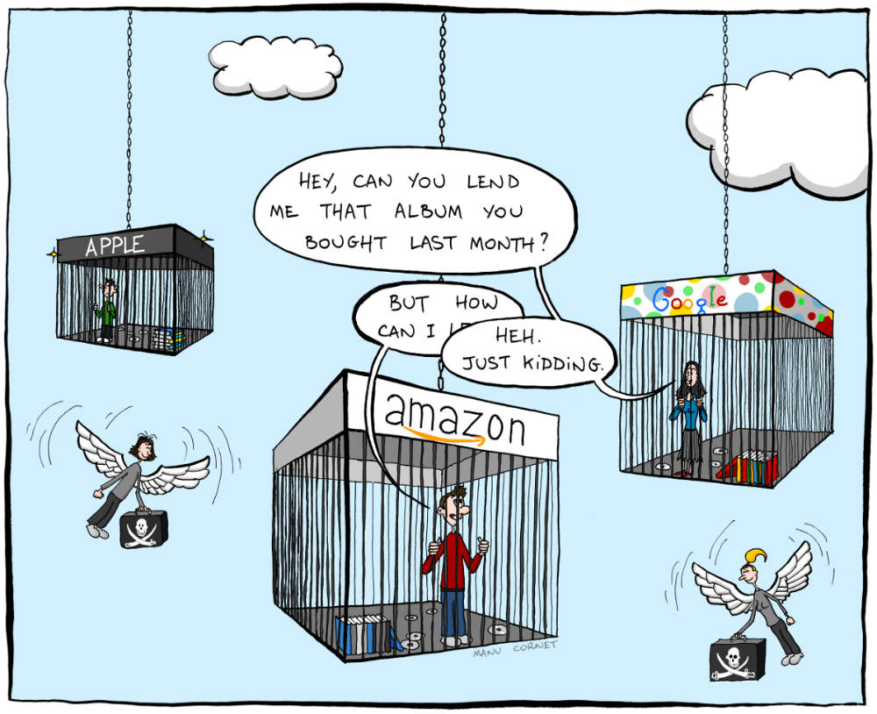
Cartoon by Manu Cornet from Bonkersworld.net. Used under Creative Commons license.
The cartoon pokes fun at how people with accounts at different stores can't access each other's music.
Most music from online stores is now DRM free - but the comic is still valid if you substitute ebook / audiobook / TV program or movie for music!
[image unavailable: steal_this_comic.png]
Cartoon from XKCD - A webcomic of romance,
sarcasm, math, and language - created by Randall Munroe
The cartoon comments on the fact that if, for example, Apple goes out of business and its DRM servers stop working then you will no longer be able to read ebooks / listen to audiobooks or watch movies that you bought from them.
The DMCA also means that it is illegal for you to try to crack the DRM on this media to be able to keep on using stuff that you have paid for!
Return to the top of this panel

Video Links - Copyright, Copyleft, Piracy and EULAs
We have selected and curated a set of videos on YouTube related to your course.
These videos are not created or owned by us.
They may display advertising and in some cases may contain limited amounts of swearing.

Notes for this Module
What to look out for and do in this module...
The FAQs are not questions that are likely to appear in exam papers - they are real questions that most people ask about the content.
Licensing and copyright infringement has an effect on the economy of a country. It reduces income for artists / creators, has a negative impact on jobs and also reduces the potential tax income for the Government as all the items that are stolen are not paid for, generate no income and are therefore not taxed.

FAQs for this module
Questions on Copyright, EULAs, Licensing and Piracy - and their answers...

Network Types FAQ
View the questions or type in the term you are looking for below…
No results were found

What is a EULA?
An End User License Agreement - a legal document that defines the rights of the software creator and you, the user of the Software.

Is Copyleft a real thing?
Yes - it is an alternative to Coryright created by Richard Stallman. It basically allows people to access and use creative works freely.

Is copyright law fair?
Many people have personal opinions on this matter.
When government extends copyright because big companies wanting to keep on making money from something that should actually be in the public domain - then I don't believe copyright is fair.
If copyright law allows someone to make a living drawing cartoons or writing books - then I do believe copyright is fair.

What is the difference between Copyleft and Creative Commons?
Copyleft has a single licensing model that prevents commercial re-use.
Creative Commons has multiple licenses that allow work to be used in different ways.

